Name: Pengcheng Jin

1. UML USER CASE

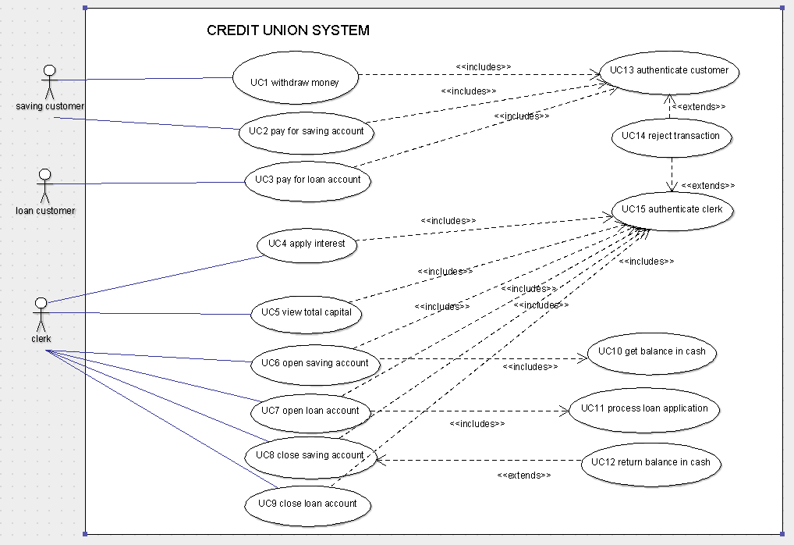

1. Use-Case descriptions

|  |  |
| --- | --- |
| ID | UC1 |
| Name | withdraw money |
| Description | Saving Customers withdraw money from clerk in the saving account and decreases the balance by the relevant amount |
| Pre-condition | Credit union system in service  Total capital is enough  Balance is enough |
| Event flow | Include UC13 “Authenticate customer”  Check balance  Tell amount of money want to withdraw to clerk  Take cash |
| Extension points | transaction abort  Balance is not enough  Total capital is not enough |
| Triggers | Saving Customer withdraw request |
| Post-condition | Balance updated |

|  |  |
| --- | --- |
| ID | UC2 |
| Name | pay for saving account |
| Description | Saving Customers Pay money to clerk, which increases the balance by their saving account. |
| Pre-condition | Credit union system in service |
| Event flow | Include UC13 “Authenticate customer”  Give money to clerk  clerk check money authenticity  Clerk increase balance |
| Extension points | transaction abort  Customer account was closed or not exist |
| Triggers | Saving Customer payment request |
| Post-condition | Balance update |

|  |  |
| --- | --- |
| ID | UC3 |
| Name | pay for loan account |
| Description | Loan Customers Pay money for clerk, which increases the balance by their loan account |
| Pre-condition | Credit union system in service  Account Balance less than 0 |
| Event flow | Include UC13 “Authenticate customer”  Give money to clerk  clerk check money authenticity  Clerk increase balance |
| Extension points | transaction abort  Payment +balance>0 is not accept |
| Triggers | Loan Customer payment request |
| Post-condition | Balance update |

|  |  |
| --- | --- |
| ID | UC4 |
| Name | apply interest |
| Description | Clerk apply a weekly interest rate of 0.01% on all outstanding loan balances in the credit union. |
| Pre-condition | Credit union system in service  System have outstanding loan balances |
| Event flow | Include UC15“Authenticate clerk”  Compute all loan amount  Compound the loan amount with 0.01% every week  Update total capital |
| Extension points |  |
| Triggers | Time pass(every week) |
| Post-condition | Loan balance update |

|  |  |
| --- | --- |
| ID | UC5 |
| Name | view total capital |
| Description | Clerk could view total capital in the credit union. |
| Pre-condition | Credit union system in service |
| Event flow | Include UC15“Authenticate clerk”  Find all accounts balance  Add them all to get total capital |
| Extension points |  |
| Triggers | Total capital query request |
| Post-condition | Get total capital |

|  |  |
| --- | --- |
| ID | UC6 |
| Name | open saving account |
| Description | Clerk could open a saving account on behalf of customer |
| Pre-condition | Credit union system in service  person didn’t have account  open saving amount of money must more than zero |
| Event flow | Include UC15“Authenticate clerk”  Include UC10“get balance in cash”  Check name whether in accounts  Check open amount of money is more than zero  Open a saving account |
| Extension points | transaction abort  Person have account already  Open money is less or equal to 0 |
| Triggers | open saving account request |
| Post-condition | Open a saving account, balance update |

|  |  |
| --- | --- |
| ID | UC7 |
| Name | open loan account |
| Description | Clerk could open a loan account on behalf of customer |
| Pre-condition | Credit union system in service  person didn’t have account  open loan amount of money must less than zero |
| Event flow | Include UC15“Authenticate clerk”  Include UC11“Process loan application”  Check name whether in accounts  Check loan amount of money whether be approved  Open a loan account |
| Extension points | transaction abort  Person have account already  Loan money is not approved |
| Triggers | loan saving account request |
| Post-condition | Open a loan account, balance update |

|  |  |
| --- | --- |
| ID | UC8 |
| Name | close saving account |
| Description | Clerk could close the saving account |
| Pre-condition | Credit union system in service  Saving amount of money must greater or equal 0 |
| Event flow | Include UC15“Authenticate clerk”  Check balance of accounts  Return balance in cash for customer  Close the saving account |
| Extension points | UC12“return balance in cash” |
| Triggers | close saving account request |
| Post-condition | Saving account close, balance update |

|  |  |
| --- | --- |
| ID | UC9 |
| Name | close loan account |
| Description | Clerk could close the loan account |
| Pre-condition | Credit union system in service  Loan account amount of money must equal 0 |
| Event flow | Include UC15“Authenticate clerk”  Check whether balance=0  Close loan account |
| Extension points | transaction abort  Balance not equal 0 |
| Triggers | close loan account request |
| Post-condition | loan account close |

|  |  |
| --- | --- |
| ID | UC10 |
| Name | get balance in cash |
| Description | Clerk get balance from customer in open saving account |
| Pre-condition | Credit union system in service |
| Event flow | Clerk get cash from customer  Open a saving account |
| Extension points |  |
| Triggers | Open saving account request |
| Post-condition | Account Balance update  Open a saving account |

|  |  |
| --- | --- |
| ID | UC11 |
| Name | Process loan application |
| Description | Clerk could judge whether process loan application |
| Pre-condition | Credit union system in service  Customer have loan apply |
| Event flow | Judge whether approval loan application  Return true or false |
| Extension points |  |
| Triggers | Open loan account request or loan request |
| Post-condition | Balance update |

|  |  |
| --- | --- |
| ID | UC12 |
| Name | return balance in cash |
| Description | Clerk return cash when customer close their saving account |
| Pre-condition | Credit union system in service  Saving account have money |
| Event flow | Check account money  Return money to customer |
| Extension points |  |
| Triggers | Close saving account request |
| Post-condition | Balance update, saving account close |

|  |  |
| --- | --- |
| ID | UC13 |
| Name | authenticate customer |
| Description | Judge whether the operator is customer |
| Pre-condition | Credit union system in service |
| Event flow | Judge the permission of customer  Return true or false |
| Extension points | UC14“reject transaction” |
| Triggers | Customer have requests |
| Post-condition | User is authenticated if credentials correct |

|  |  |
| --- | --- |
| ID | UC14 |
| Name | reject transaction |
| Description | If not the allow person, reject it |
| Pre-condition | Credit union system in service  Authenticate request |
| Event flow | judge the permission of people, if return false, reject transaction |
| Extension points |  |
| Triggers | Authenticate clerk and Authenticate loan |
| Post-condition | Reject the transaction |

|  |  |
| --- | --- |
| ID | UC15 |
| Name | authenticate clerk |
| Description | Judge whether the operator is clerk |
| Pre-condition | Credit union system in service |
| Event flow | Judge the permission of clerk  Return true or false |
| Extension points | UC14“reject transaction” |
| Triggers | Clerk have requests |
| Post-condition | User is authenticated if credentials correct |

1. 5 functional requirements

* only clerk can get the information of total capital in Credit Union
* open a saving account must have a non-zero positive amount of money
* open a loan account must have a non-zero negative amount of money
* each of loan application must no more than £5000, no more than 5% of total capital held by the credit union, and the credit union has enough capital to loan the money.
* Apply a weekly interest rate of 0.01% on all outstanding loan balances in the credit union

1. 5 non-functional requirements

* System must easy to use.

The new clerk may be employed, so the system must easy to use that the new clerk can quickly finish the job training. It can reduce cost of training in staff.

This requirement could verifiable by let layman to try to use it. If 80% of the functions were explored within 30 minutes, so It is easy to use.

* System should have expandability to extend new operations when Credit Union becoming greater.

More and more customers will choose this credit union, so it want to increase income through add new business. So the system must have expandability to explore new function.

This requirement could verifiable by add a new simulated functions(such as currency exchange) and the original system should not be influenced.

* System response time must be limited in 3 seconds when clerk operate system.

More and more customers were added. So the query or change operate will getting slow.

This requirement could verifiable by add a timer for system running.

* System should have an abnormal input check.

Clerk may enter wrong data that could cause system failure. So system should have a input check. This requirement could verifiable by clerk enter format wrong amount to test system stability.

* System must have good restorability when it abort or restart.

add a log that could recover or rollback the latest state.

Sudden situation may occur, such as power off and software shutdown. The system must rollback the latest state to recover.

This requirement could verifiable by cut off the electricity when transaction is running, determine the balance is correct or not.

1. UML Sequence Diagram

